Project description
Hip and knee osteoarthritis is a leading cause of disability and source of societal cost in older adults. Global prevalence of osteoarthritis is increasing and the burden of the disease will rise. The medical cost of osteoarthritis in various high-income countries has been estimated to account for between 1% and 2.5% of the gross domestic product of these countries, with hip and knee joint replacements representing the major proportion of these health-care costs. Joint replacement surgery is a clinically relevant and cost-effective treatment for end-stage osteoarthritis. The characteristics of end-stage osteoarthritis include joint pain, which disrupts normal sleep patterns and causes a severe reduction in capable walking distance and marked restriction of daily activities. Hence, the aim of knee and hip replacements is to alleviate pain and disability in daily functioning.
However, up to 25% of patients presenting for total joint replacement continue to complain of pain and disability 1 year after well performed surgery. With data available on thousands of patients, the question arises to what extent it is possible to predict treatment success. This could be useful in supporting doctors in deciding whether knee replacement is indicated, and could help give patients a more personalised assessment of what to expect of treatment.

Result
By the end of this course, you should be able to understand and reproduce the analysis in this paper by Huber et al. (2019) ↗ where PROMs following hip and knee replacement surgery are predicted using supervised learning.

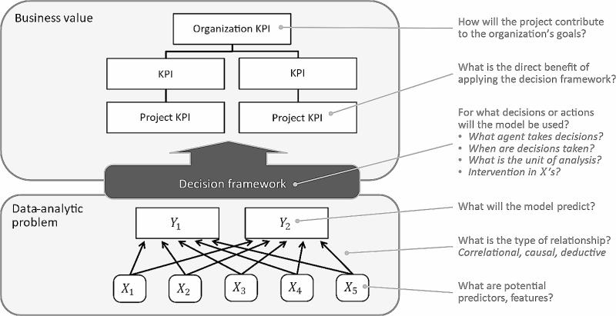
Business Value
The hospitals executing the hip and knee replacements to manage the hip and knee osteoarthritis of people are facing an enduring pressure of allocating resources in order to increase patient’s health. As these hospitals, together, have an impact of 1% to 2.5% of the GDP, it becomes highly important to increase the success rate or clinical quality of managing the pain at the patients.
Organization KPI:
- Population-level health outcomes of patients undergoing hip and knee replacement surgery, measured in terms of resolving the issues arising from osteoarthritis.
- Value-based clinical quality of joint replacement surgery, defined the portion of resources (1% to 2.5% of annual GDP) that contributes to successful outcomes of surgeries regarding hip and knee replacement.
Project KPI:
- Increase the portion of patients with positive PROM scores within 1 year after surgery for knee surgeries.
- Increase the portion of patients with positive PROM scores within 1 year after surgery for hip surgeries.
The outcome of the project (the model to be created) must help in determining which patients are eligible for surgery. In short, a set of characteristics within the dataset should determine whether or not to operate.
Outcome variables
- Y₁: Expected PROM (or PROM improvement) for knee replacements.
- Y₂: Expected PROM (or PROM improvement) for hip replacements.
Predictor variables
- To be determined based on dataset.

